RDBMS LAB PRACTICAL - 4

AIM: DML
• INSERT Statements
• Updating Column Values and Deleting rows

- Create Table for Instagram Users Question: Create a table named InstagramUsers to store user information with the following requirements: • user_id: A unique identifier for each user (primary key). • username: The username of the user, which is unique and not null. • email: The email address of the user, which is unique and not null. • created_at: The date when the user account was created, with a default value of the current date.

Sol. Syntax: CREATE TABLE table_name (column1 datatype, column2 datatype); Code: CREATE TABLE users( user_id NUMBER(10) PRIMARY KEY, username VARCHAR2(50) UNIQUE NOT NULL, email VARCHAR(100) NOT NULL UNIQUE, created_at DATE NOT NULL DEFAULT sysdate)

OUTPUT:

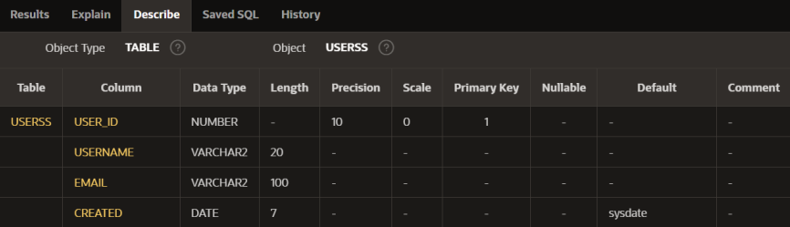

- Insert Data into InstagramUsers Table • Question: Insert the following users into the InstagramUsers table: 1. user_id: 1, username: 'john_doe', email: 'john.doe@example.com' 2. user_id: 2, username: 'jane_smith', email: 'jane.smith@example.com'

Sol. Syntax: INSERT INTO table_name (column1, column2, ...) VALUES (value1, value2, ...); Code: INSERT INTO userss(user_id,username,email,created) VALUES (1,'john_doe','john.doe@example.com',sysdate); INSERT INTO userss(user_id,username,email,created) VALUES (2,'jane_smith','jane.smith@example.com',sysdate);

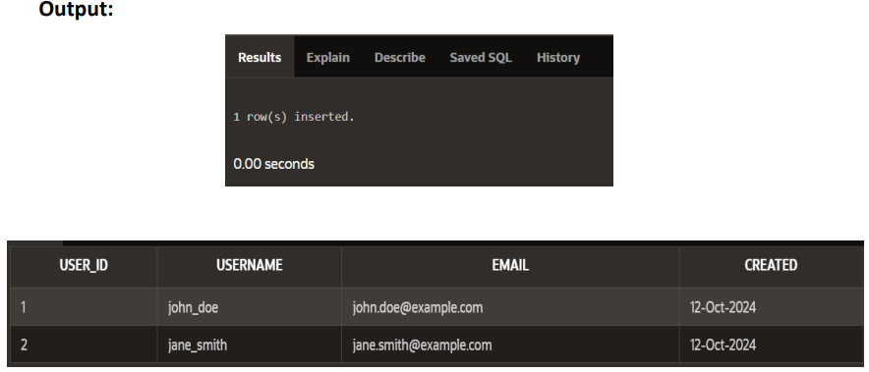

3.Update User Email and Add Default Profile Picture Question: 1. Update the email of the user with user_id = 1 (John Doe) to john.new@example.com. 2. Add a profile_picture column to the InstagramUsers table, with a default value of 'default_profile.jpg'. Then update the table to give all existing users the default profile picture if none is specified.

Sol. Syntax: UPDATE table_name SET column_name='john.new@example.com' WHERE condition; ALTER TABLE table_name add new_column_name datatype constraint; Code: UPDATE userss SET email='john.new@example.com' WHERE user_id=1; ALTER TABLE userss ADD profile_picture varchar2(200) DEFAULT 'default_profile.jpg';

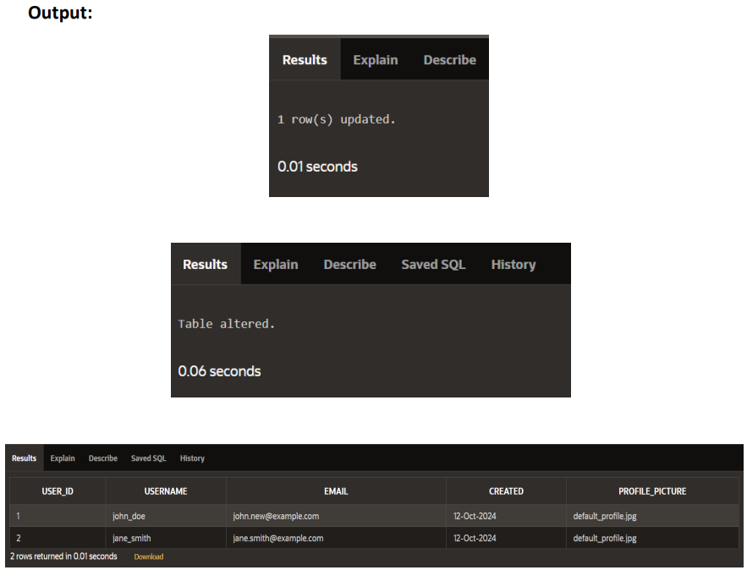

4.Insert New Users with DEFAULT Values Question: Insert a new user, Emily Clark, into the InstagramUsers table, but do not specify the created_at or profile_picture values (allow the default values to be used).

Sol. Syntax: INSERT INTO table_name (column1, column2, ...) VALUES (value1, value2, ...); Code: INSERT INTO userss(user_id,username,email) VALUES (3,'emily_clarke','emilly.@example.com')

OUTPUT:

